Task Description:

Launch Linux EC2 instances in two regions using a single Terraform file.
AWS configured , terraform installed.
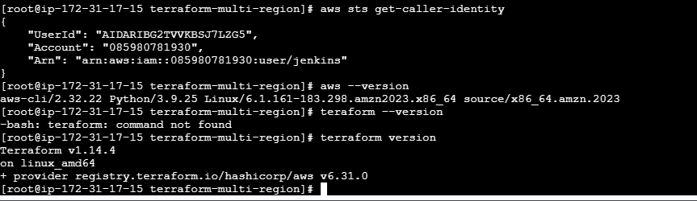
Created a script file main.tf
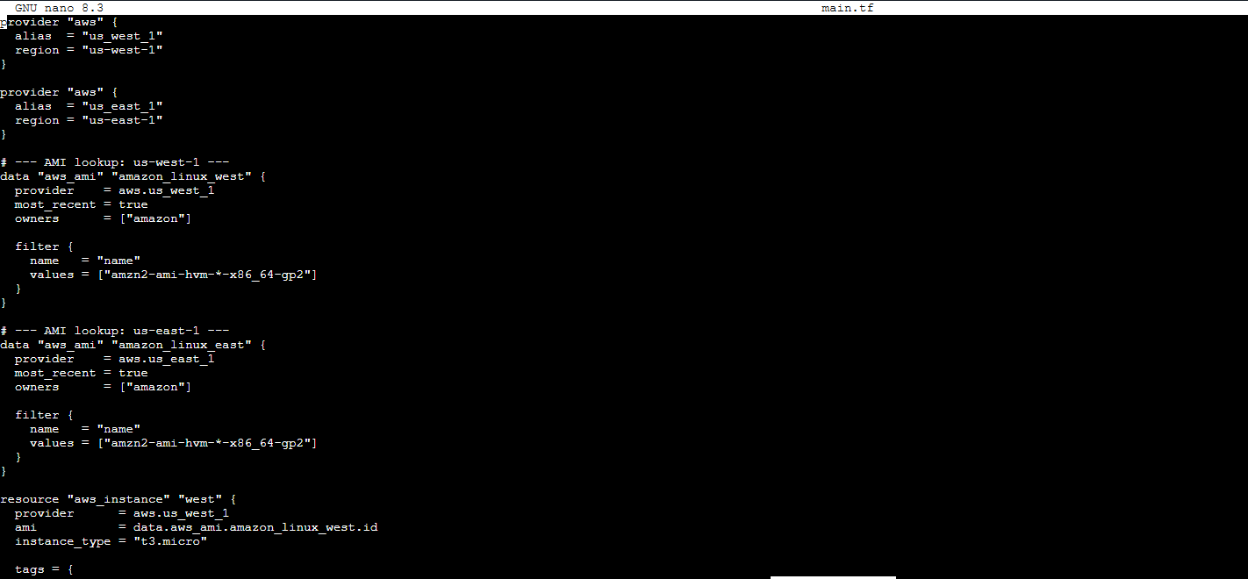
Initiated and applied terraform
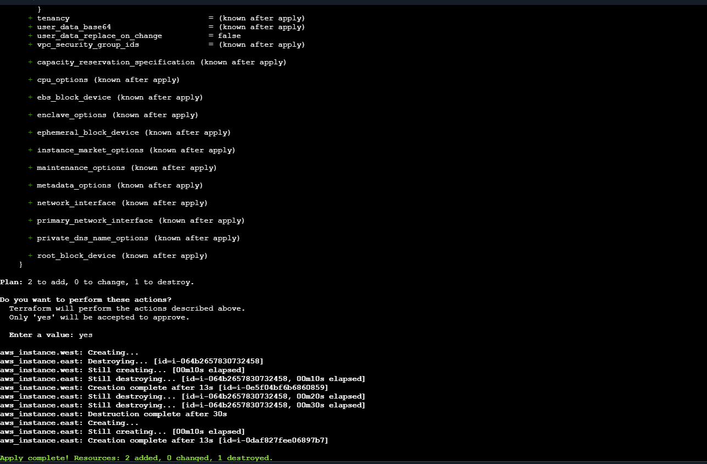
Created two ec2 instances on different regions
